Introduction to the Power BI Service

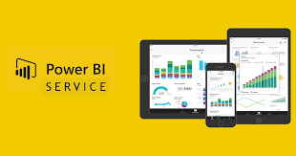

# LAB 1: Create a Power BI Service Dashboard

This tutorial is an introduction to the features of the *Power BI service*. In this tutorial, you connect to data, create reports, and a dashboard, and ask questions about your data. The exercises show you how to work with data on a dashboard and design dataset visualizations.

**Create a Power BI service Account**

You need a Power BI Pro or Premium Per User (PPU) license to create content in Power BI. **Sign in for Power BI Service using your university email**! Complete the wizard to get a free license. <https://app.powerbi.com/signupredirect?pbi_source=webbefore> .

**Get the Data for the Power BI Service Report**

We create a dataset from a Microsoft Excel file that contains financial data.

1. Open the Power BI service (app.powerbi.com) in your browser, if it is not already open from the previous step.
2. Download the Excel file that has the Financial Sample data from datasets folder.

## Learn how to Publish Excel Files to the Power BI Service

This step is not needed for the report but I would like you to know how to publish Excel files to the Power BI Service.

1. Open the **Financial Sample** Excel File on your local computer. Enable Editing.
2. Click on the **File** menu and then click **Publish**. The app might ask you to login again to the Power BI Service. Use your university account to login to the Power BI Service Cloud Platform.
3. Select the option **Upload** as per the image below.
4. The Excel file should be in the "**My Workspace**" folder in your Power BI Service platform.  
     
   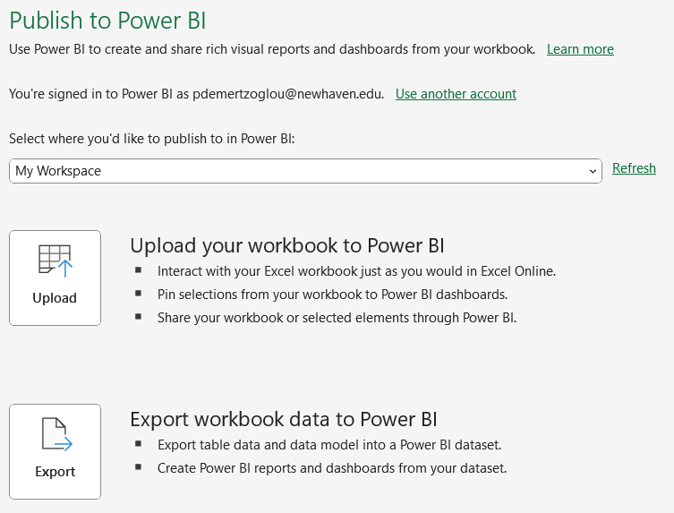

## Setup a Report and Data Connection on the Power BI Service

1. There are two ways to create a new report. You can click on **New/Report** in My Workspace or **click the plus button** towards the top of the left pane.

1. In the next screen click on Excel.

1. Next, click on **Upload** and then click **Browse** and select the Financial Sample file from your local computer. If you are not signed in, click on **Sign In** at the bottom of the screen. Now, your Power Query window should look like the following: Click **Next** at the bottom right of the Power Query window.

1. In the Power Query window, **click on financials** to select the worksheet and then **click Create**.

1. The Power BI service opens the new report in **My workspace**. The report canvas is blank and shows the **Filters**, **Visualizations**, and **Data** panes.

## Create a Visual in the Power BI Service Report

We will add a column chart to the report to build a visualization of the data.

1. In the **Data** pane, click on the arrow next to the **financials** heading to show the data fields.

Some data items have a sigma symbol (Σ) next to the name. Power BI displays the sigma next to data that has numeric values.

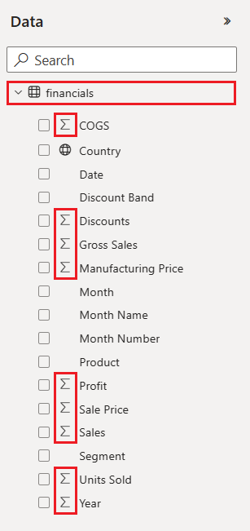

1. Select the **Gross Sales** measure and then the **Date** descriptor.

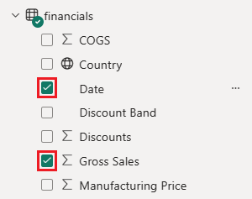

Power BI analyzes the selected data and creates a column chart visualization.

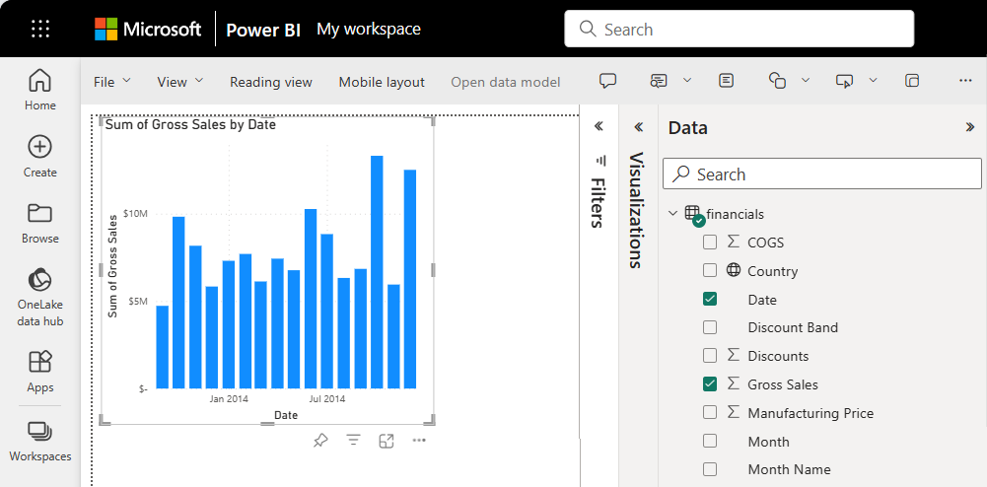

If you select the **Date** item before you select the **Gross Sales** item, Power BI creates a table rather than a column chart.

Let's try a different display of the selected data. Line charts are good visuals for showing changes in values over time. In the **Visualizations** pane, select **Line chart**.

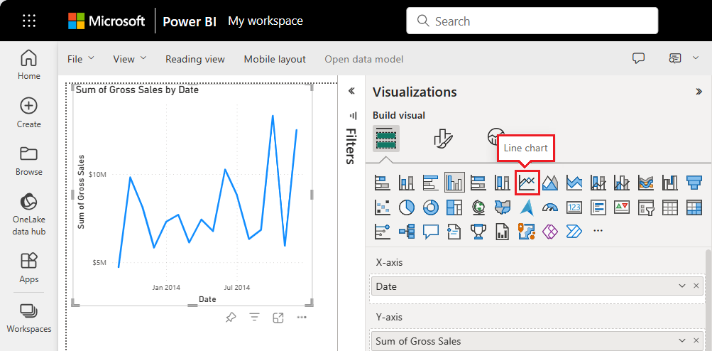

1. The line chart looks interesting, so let's *pin* the visualization to a dashboard. Select the **Pin** icon on the visualization.

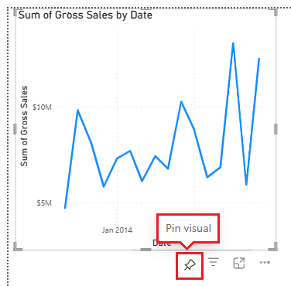

When the report is new, you're prompted to save the report before you can pin the visualization to a dashboard. Enter a name for the report, such as **Financial Sample report**, and select **Save**.

Power BI saves the report to the selected location. The default is **My workspace**. Power BI shows the report in Reading view.

1. Position the mouse over the visualization and select the **Pin** icon again. The **Pin to dashboard** pop-up dialog opens.
2. In the pop-up dialog, select **New dashboard**, and enter a name for the dashboard, such as **Financial Sample dashboard**. Click **Pin**.

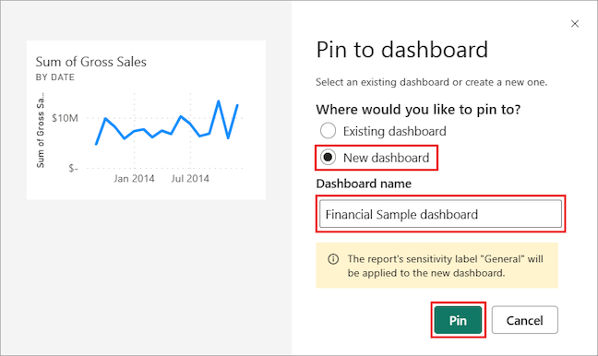

Power BI displays a success message after the service adds the visualization to the dashboard. The success dialog includes an option to create an optimized layout of the dashboard for your mobile device.

1. In the message dialog, select **Go to dashboard**.

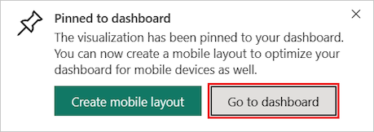

After you pin a visualization, it's pinned on the dashboard as a *tile*. The data in the visualization stays up-to-date so you can track the latest value at a glance.

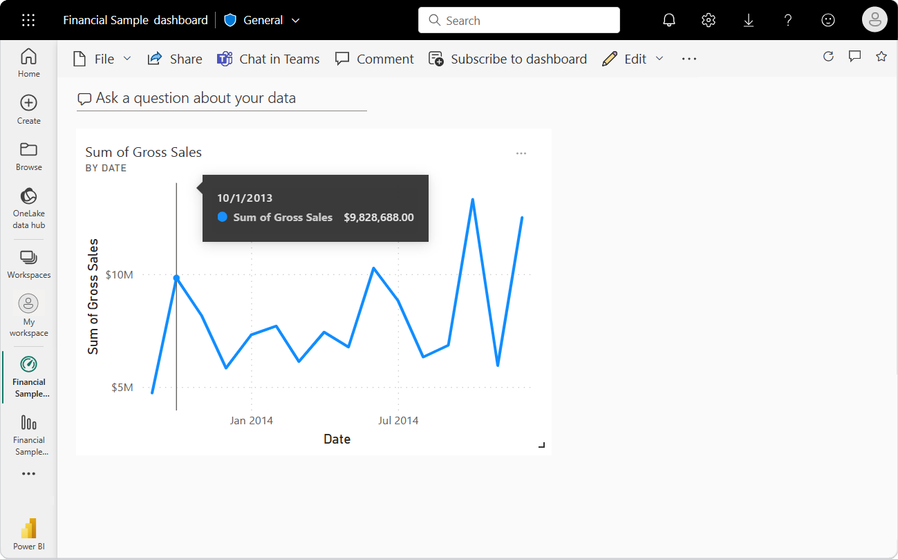

After you pin a visualization, if you change the visualization type in the report, the pinned visualization on the dashboard **doesn't** change. To see the new visualization, pin it to the dashboard to create another tile. The use of multiple tiles lets you have more than one visualization of the same data on your dashboard!

1. Now select the tile on the dashboard:

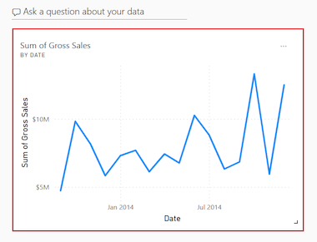

The Power BI service returns you to the report editor where you can refine the visualization:

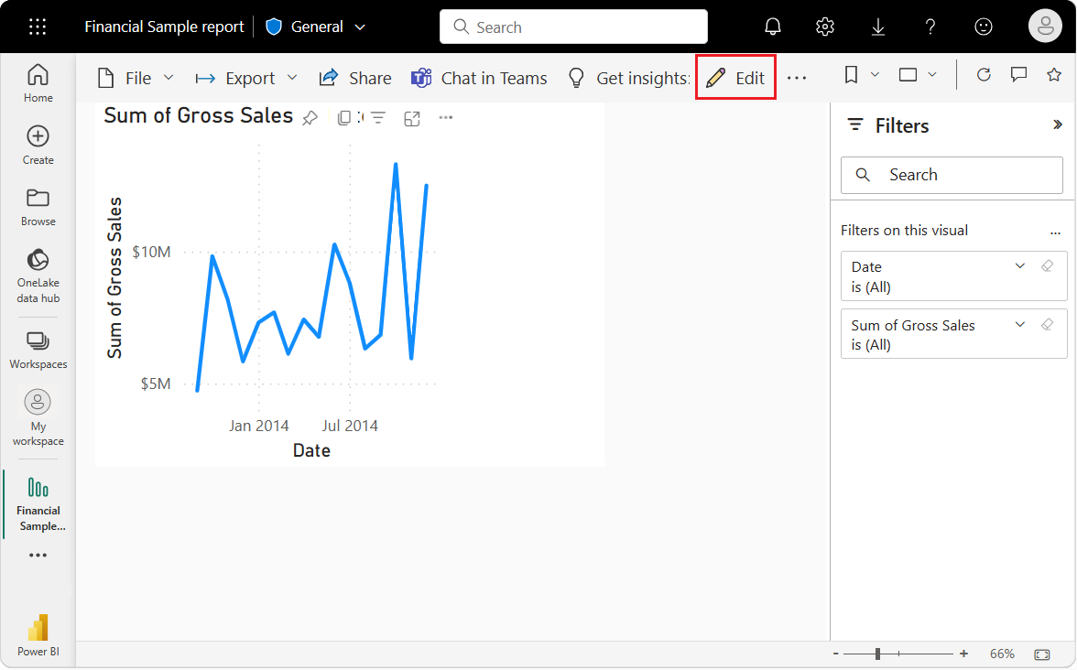

You can select **Edit** to return to Editing view and continue to explore and pin tiles.

**Q&A with Visualizations**

For a quick exploration of your data, try asking a question in the Q&A question box. Q&A lets you ask natural-language queries about your data.

In the Power BI service, you can find the Q&A question box in a dashboard as "**Ask a question about your data"** at the top of the tile view:

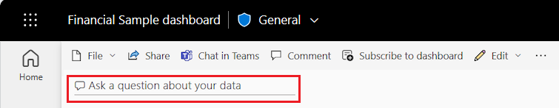

When you select the Q&A box, Power BI opens an extended view to help you ask questions and find answers.

Let's try out the Q&A experience for a dashboard.

1. In the Power BI service, from the left pane, select **My workspace**, and then select the **Financial Sample Dashboard**.

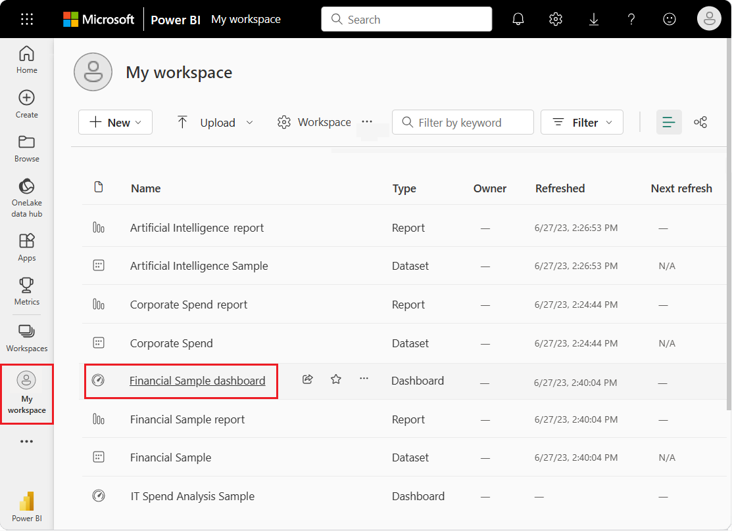

1. At the top of the tile view, select **Ask a question about your data**. The view expands and Q&A offers several suggestions. If you cannot see the Q&A feature try to change the browser you are logging in.

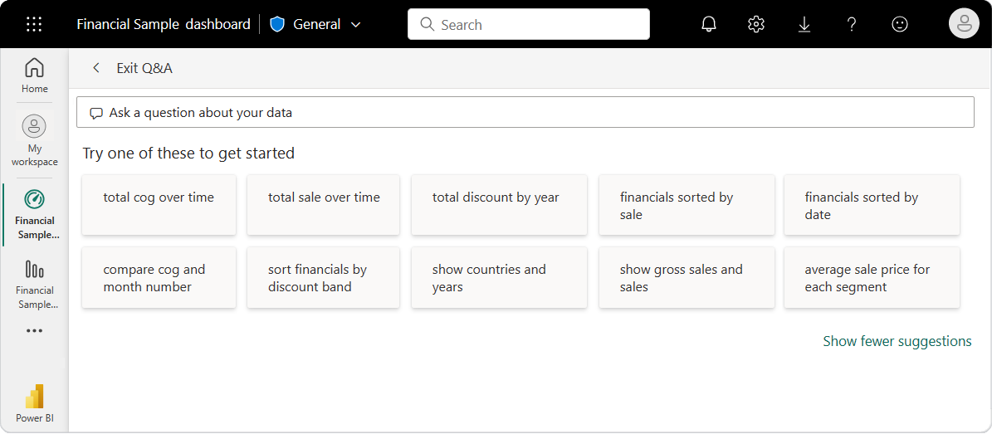

You can select a suggestion and see the results or enter your own question in the Q&A box.

1. In the Q&A box, enter the question **what is the average sale**. As you type, Q&A tries to pattern match your text entry for recognized questions.

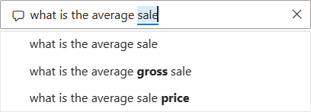

Q&A searches for an answer and displays the answer as a *card* visualization.

1. At the top right, select **Pin visual** and pin the visualization to the Financial Sample dashboard. Select the default option "**Existing Dashboard**" and click **Pin**. Select "Existing Dashboard". This is the place where your visualization will display.

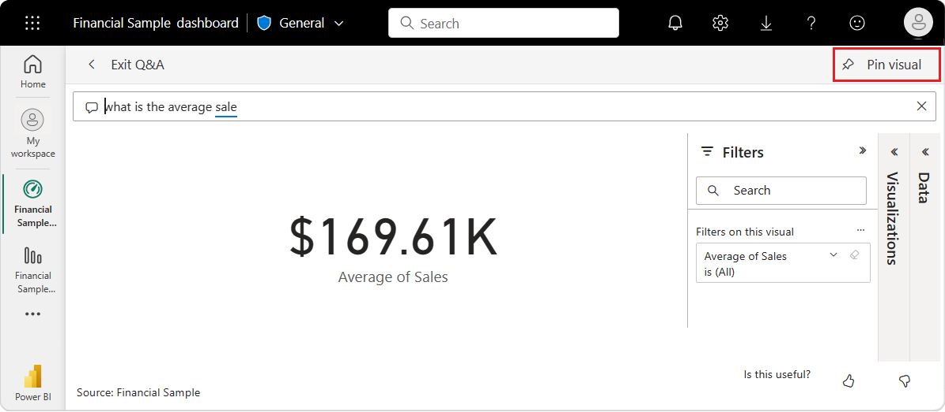

1. Try another question in the Q&A box. Enter **total profit by country as map**. If the visual does not display as a map, select the map visual from the visualizations pane.

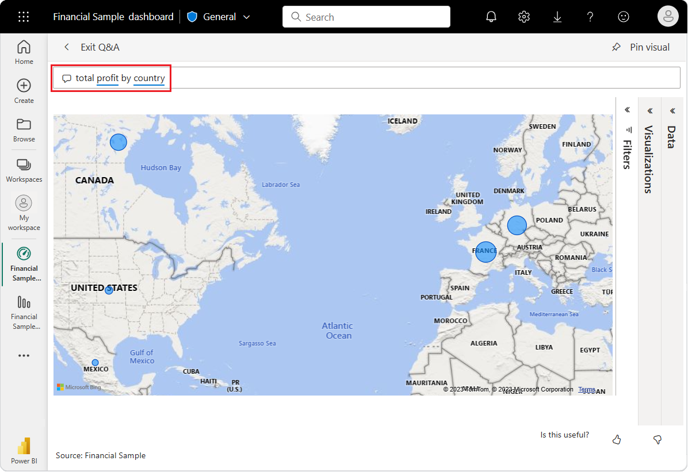

1. Pin the country/region map visualization to the Financial Sample dashboard.
2. In the success dialog, select **Go to dashboard** to view the newly pinned tiles on your dashboard.
3. On the dashboard, select the pinned country/region map. Notice how the visualization opens in Q&A.
4. Place the cursor after **by country** in the Q&A box and enter **as bar**. Power BI creates a bar chart with the results.

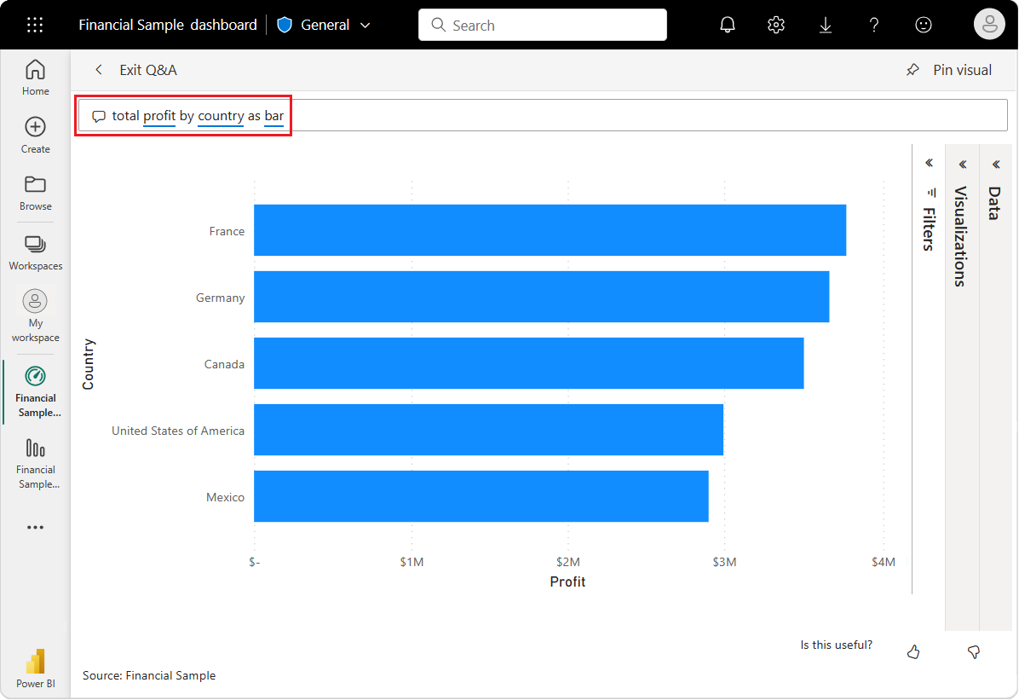

1. Pin the bar chart to your Financial Sample dashboard.
2. At the top, select **Exit Q&A** to return to your dashboard.

You now have four pinned tiles on your dashboard: line chart, numeric average, country/region map, and bar chart.

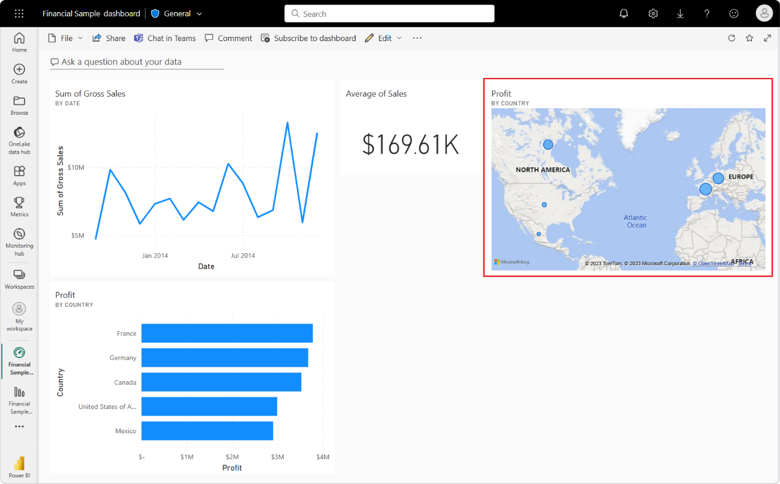

## Pin different views of data with multiple tiles

Notice that although you changed the map visualization to a bar chart in Q&A, the corresponding tile on the dashboard still shows a map.

When you pin a tile to a dashboard, the tile always displays the data by using the original visualization type. If you change the visualization type for an existing tile, and pin the tile, Power BI creates a new tile with the new visualization type. The original tile remains unchanged. The use of multiple tiles enables you to have more than one visualization of the same data on your dashboard.

## Adjusting tile layouts on the dashboard

Tiles on the dashboard can be rearranged and adjusted to make better use of the space. You can change tile sizes, reposition tiles, and work with tile details to improve the layout.

### Adjust tile size

Let's change the size of the *Gross sales* line chart tile to be the same height as the *Average of Sales* tile.

1. Select the lower-right corner of the *Gross sales* line chart tile and drag the tile outline upward to reduce the overall tile height.
2. Continue to drag the tile outline upward until the tile snaps into place at the same height as the *Average of Sales* tile.
3. When the tile has the desired height, release the mouse.

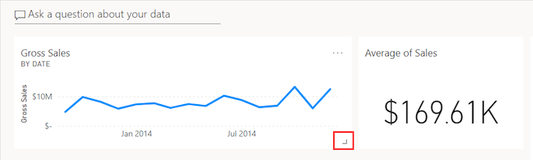

The two tiles are now the same height.

### Modify tile details

Sometimes changing **Tile details** can improve the dashboard presentation.

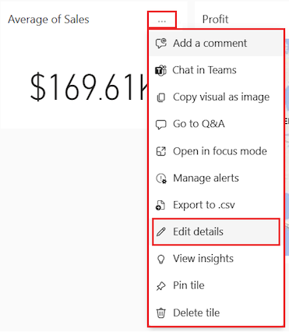

1. On the *Average of Sales* tile, select **More options (...)** > **Edit details**.
2. In the **Tile details** dialog, in the **Title** box, enter **Sales Average**.
3. Select **Apply**.

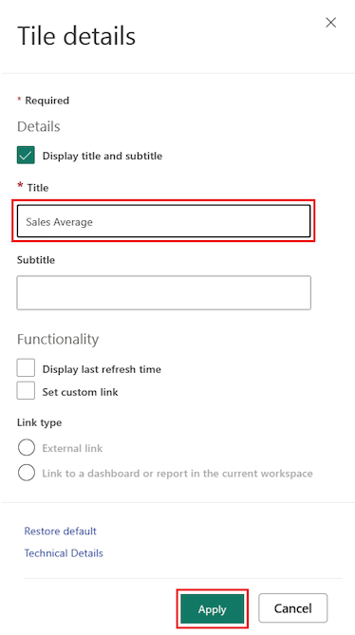

### Arranging the position of tiles

You can move a tile by selecting the tile and dragging it to a new location.

1. Select the country/region map tile and drag the tile to the right of the bar chart.
2. When the tile's in the desired position, release the mouse.

Notice that these two tiles take up more width on the dashboard than the *Gross sales* line chart tile and the *Sales Average* tile. You can improve the layout by increasing the overall width of the line chart tile.

Below is an example of the dashboard with the improved layout. You can manipulate the size and position of the existing tiles at will up until you have a layout to your liking.

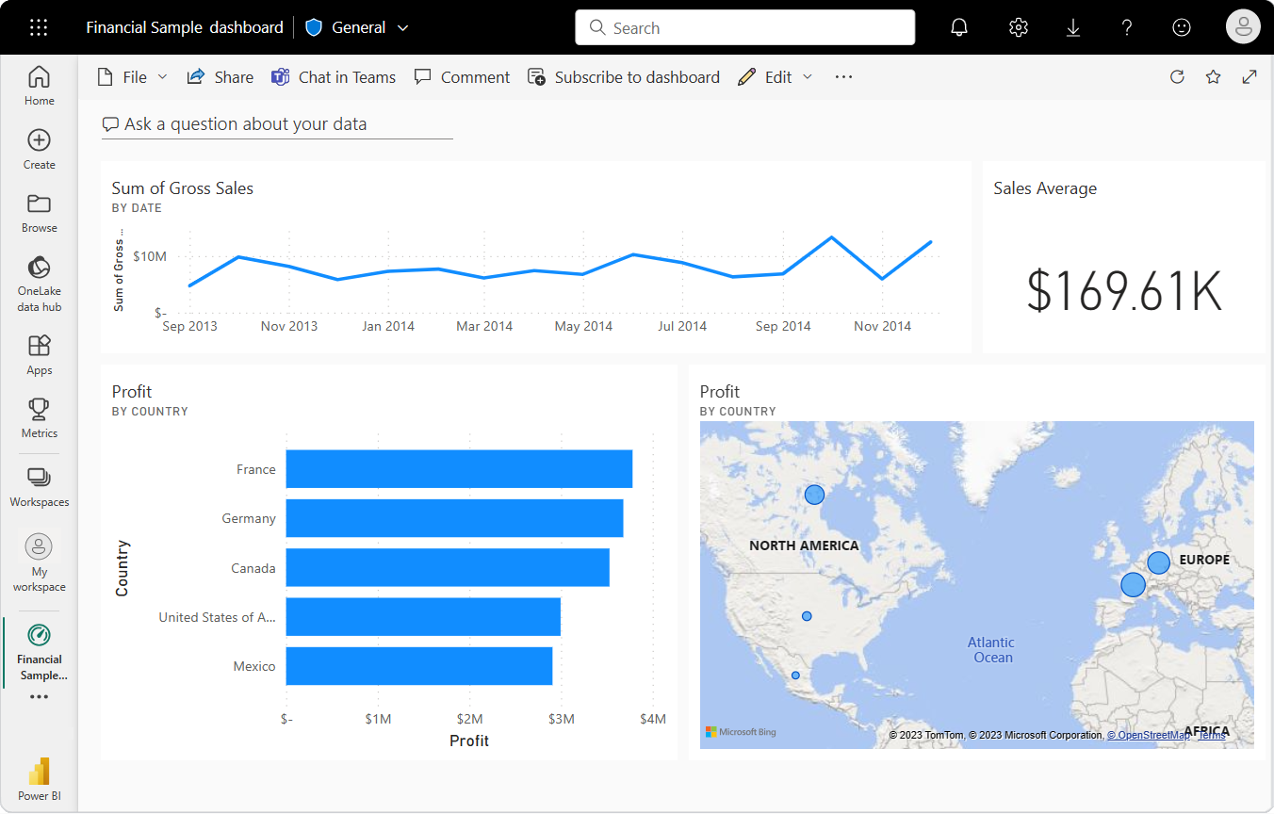

# LAB 2: From Excel Formulas to the Power BI Service

Your manager wants to see a report on your latest sales and profit figures by the end of the day. However, the latest data is in files on your laptop. In the past, it's taken hours to create a report, and you’re beginning to feel anxious. No worries. With Power BI, you can create a stunning report and share it in Microsoft Teams in no time!

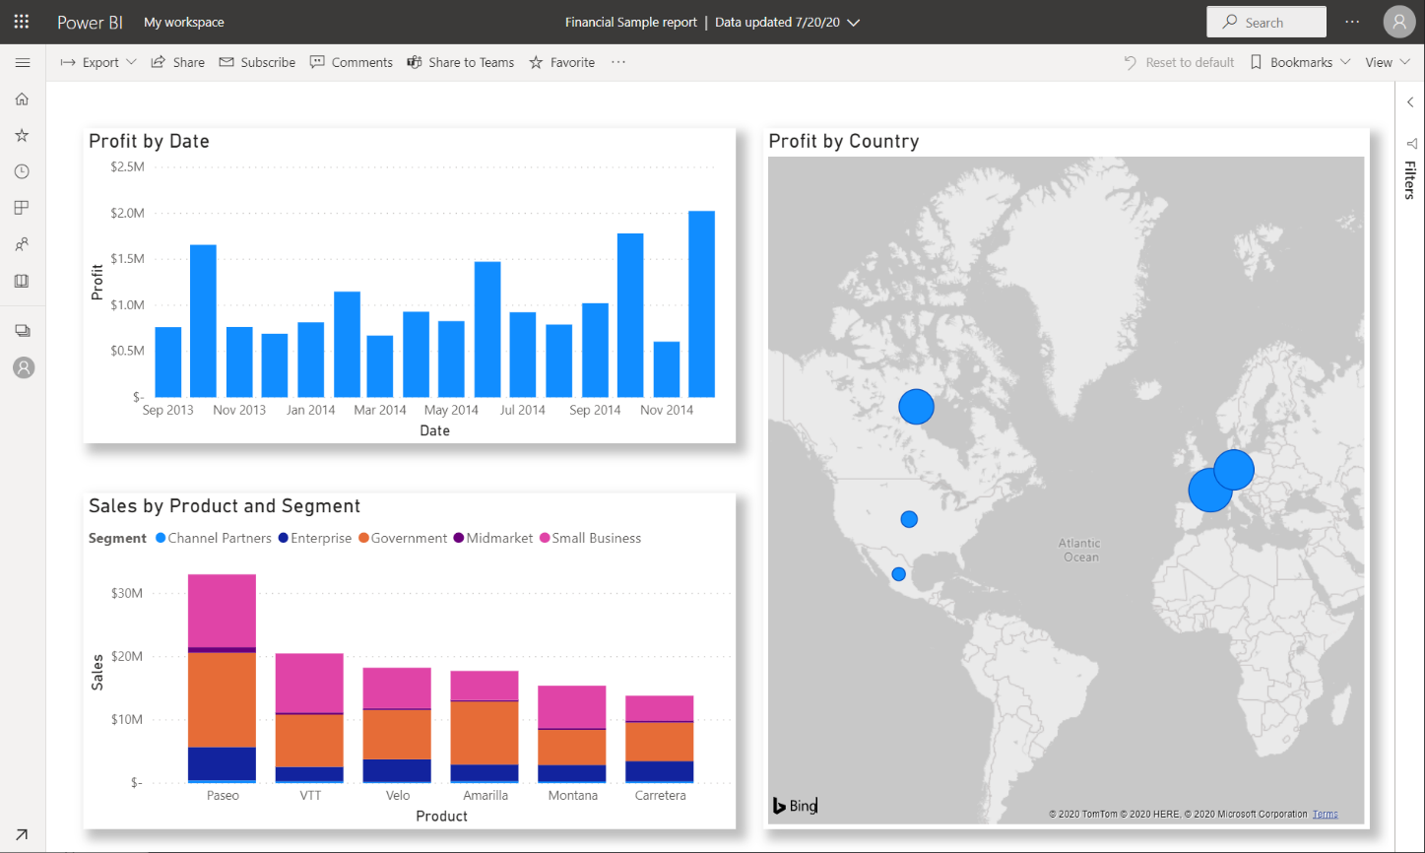

In this tutorial, we create a new report, and share it with colleagues in Microsoft Teams, all from within Power BI. You'll learn how to:

* Prepare your data in Excel.
* Download sample data.
* Build a report in the Power BI service.
* Pin the report visuals to a dashboard.
* Share a link to the dashboard.
* Share the dashboard in Microsoft Teams

## Get the Data for your report

1. In the left pane of your screen **click** on **My Workspace**.
2. Click **New** and select **Report**.

1. The report opens in Editing view and displays the blank report canvas.
2. In the next screen click on Excel.
3. Next, click on **Upload** and then click **Browse** and select the Financial Sample file from your local computer. If you are not signed in, click on **Sign In** at the bottom of the screen. Now, your Power Query window should look like the following: Click **Next** at the bottom right of the Power Query window.

1. In the Power Query window, **click on financials** to select the worksheet and then **click Create**.

1. The Power BI service opens the new report in **My workspace**. The report canvas is blank and shows the **Filters**, **Visualizations**, and **Data** panes.

## Build Your Report

1. Your manager wants to see profit over time. From the **Fields** pane, drag **Profit** to the report canvas. By default, Power BI displays a column chart with one column.

1. Now expand the hierarchy in the Date field and drag the year and the month to the same visual. Your visual should be similar (maybe not identical) to the visual below:

If your chart values don't look as you expect, check your aggregations. For example, in the **Values** well, select the **Profit** field you just added and make sure the data is being aggregated the way you want. In this example, we're using **Sum**.

## Create a map

Your manager wants to know which countries/regions are the most profitable. Impress your manager with a map visualization.

1. Click on a blank area on your report canvas.
2. From the **Fields** pane, drag the **Country** field to your report canvas, then drag the **Profit** field to the map.

Power BI creates a map visual with bubbles representing the relative profit of each location.

## Create a visual showing sales by Product and Market Segment

1. Click on a blank area on your report Canvas.
2. In the **Fields** pane, select the **Sales**, **Product**, and **Segment** fields.

Power BI creates a clustered column chart.

1. Change the chart to a **Stacked column chart**.

1. To sort the chart, select **More options** (**...**) > **Sort Axis / Sum of Sales**.

## Spruce up the visuals

1. Click on the **Sum of Profit by Year and Month** visual. In the visualizations pane, click the general tab. In the **Title** section, change **Text size** to **16 pt**. Change the font color to white and the background color to red.
2. Select the **Sales by Product and Segment** stacked column chart. In the **Title** section, change title **Text size** to **16 pt**.
3. Select the **Profit by Country** map. In the **Map settings** section change the style to **Grayscale**. In the **Title** section, change title **Text size** to **16 pt**.
4. Save your report with the name **Sales Report**

## Share a link to your dashboard

Now it's time to share your dashboard with your manager. You can share your dashboard and underlying report with any colleague who has a Power BI account. They can interact with your report, but they can't save changes. If you allow it, they can reshare with others or build a new report based on the underlying dataset.

1. To share your report, at the top of the dashboard, select **Share**.

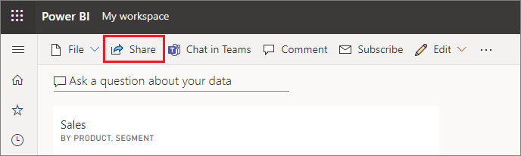

1. In the **Share dashboard** screen, enter the email addresses of the recipients in the **Enter a name or email addresses** field and add an optional message. (Do not enter the professor's email)
2. Select the option to **Send an email notification**. Choose any other options you want:  
   * **Allow recipients to share this dashboard**
   * **Allow recipients to build content with the data associated with this dashboard**

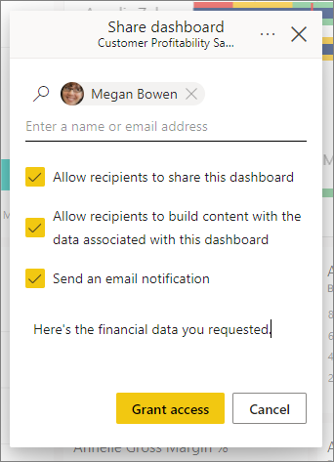

1. Select **Grant access**.

**Share to Microsoft Teams**

You can also share reports and dashboards directly to your colleagues in Microsoft Teams.

1. To share in Teams, at the top of the dashboard, select **Chat in Teams**.

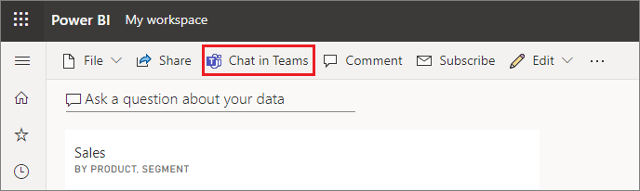

1. Power BI displays the **Share to Teams** dialog. Enter the name of a person, group, or channel and select **Share**.